USER INTERFACE AND DESIGN EXPERIMENT – 9
Name: Sri Vaishnavi A Roll No: 240701529

AIM:
The aim is to design input forms that validate data, such as email and phone number, and display error messages using HTML/CSS and JavaScript with Validator.js

PROCEDURE:
Step 1:
Setting Up the HTML Form Start by creating an HTML form with input fields for the email and phone number.
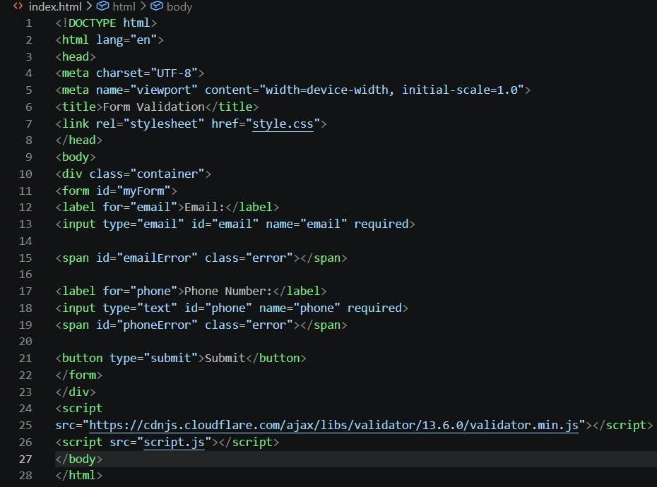

Styling the Form with CSS Next, add some basic styling to make the form look nice.
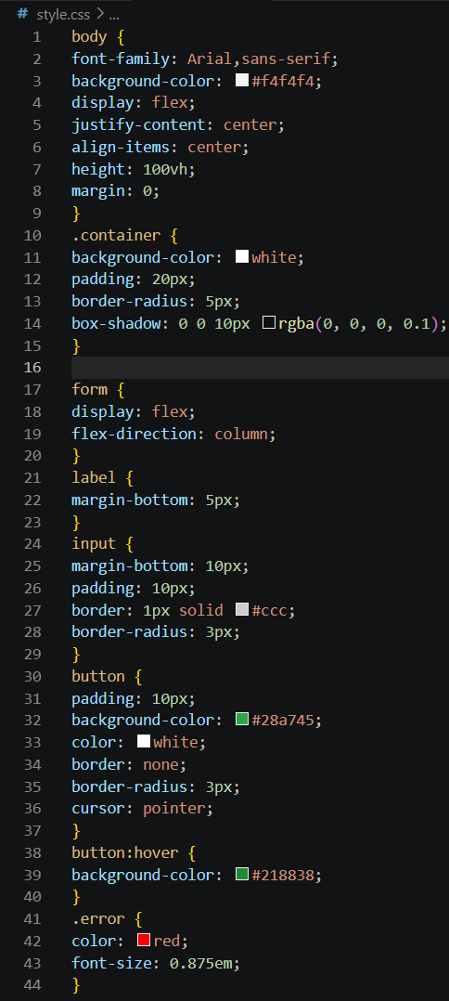

Adding JavaScript for Validation Finally, add JavaScript to validate the input fields using Validator.js and display error messages
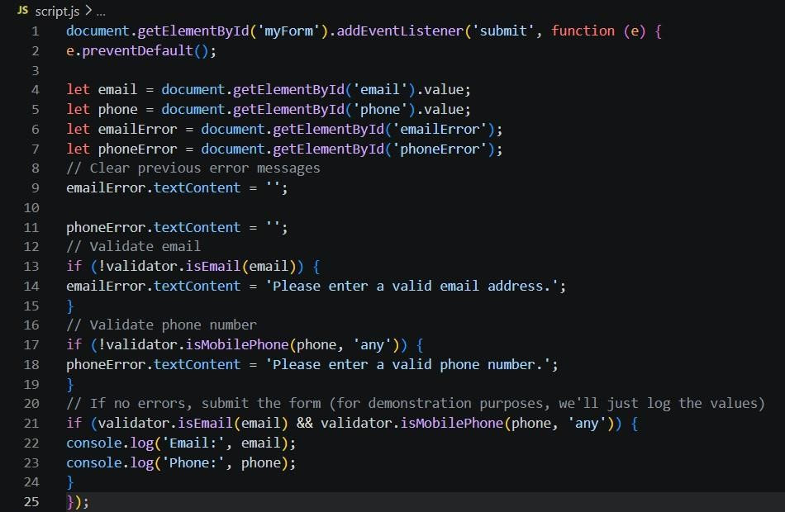

OUTPUT
For valid email and phone no. :
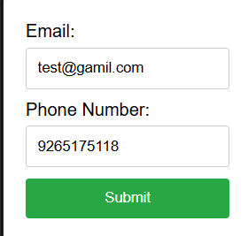

Error message for invalid email:
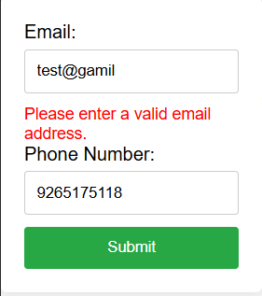
Error message for invalid phone no. :
